

XMO User Login Guide

Subtitle: How to login VCS AVD VDI’s

Author: Rasika Dhadve (Infosys)
Editor: Sujana Shetty (Infosys)



Table of Contents
Abbreviation 3
Overview: 3
Access to the new Environment via ‘Remote desktop client’ (Recommended) 4
Prerequisites 4
Install RD Client from Microsoft in BYOD devices 4
Install RD client from Company portal in DTAG owned devices 7
Login & Access VDI 7
Custom settings in Remote desktop client 9
Set VDI to launch in only desired screen when you have multiple monitor 9
Change multi-screen to single screen 10
Access windows Key combination (Windows, Alt+Tab) in AVD VDI session 11
Access Via Web client 12
Prerequisites 12
Login via Web Client access VDI 12
Contact VCS AVD Team: 14
SNOW Process: 14
NPM mailbox: 15
Frequently Asked Questions: 16
Basic Issues which you may face in VDI 16

Abbreviation
Abbreviation | Full Form | Description
VDI | Virtual desktop infrastructure | Virtual Desktop Infrastructure (VDI) is a technology that employs virtual machines to manage and deliver virtual desktops.
AVD | Azure Virtual Desktop | Azure Virtual Desktop on Microsoft Azure is a desktop and app virtualization service that runs on the cloud.
RD Client | Remote Desktop Client | The Microsoft Remote Desktop client is used to connect to Azure Virtual Desktop to access your desktops and applications.

Overview:
Azure Virtual Desktop (AVD) is a cloud-based VDI service from Microsoft, hosted in Azure data centers. As part of the XMO Virtual Client Services (VCS), we offer AVDs managed by the Infosys VCS team. Please note that, as of now, XMO VCS-managed AVDs are available only in the APAC region and are hosted in the Japan East Azure location.
AVDs can be accessed in two methods.
- Access Via “Remote desktop client”. Recommended
- Access Via Web client

Each method is described in below upcoming sections.
All the crucial information is listed here for those who don't require detailed instructions:

No | Key Fact | Link to chapter
1 | Microsoft Web client URL. | Enter URL in your preferred browser https://client.wvd.microsoft.com/arm/webclient/index.html
2 | User should have TBDIR account created, and MFA is configured and M365 license assigned.  Note: B2B accounts are not supported, as AVD currently supports only DTAG domain entra ids.
3 | If you already have Remote desktop client installed | Click on Subscribe and enter your ‘shortID@tbdir.net’, follow the onscreen prompts and complete authentication

Access to the new Environment via ‘Remote desktop client’ (Recommended)
Remote desktop clients are supported on below platforms.
Platform | Documentation and download links | Version information
Windows | Connect to Azure Virtual Desktop with the Remote Desktop client for Windows | What's new
Web | Connect to Azure Virtual Desktop with the Remote Desktop client for Web | What's new
macOS | Connect to Azure Virtual Desktop with the Remote Desktop client for macOS | What's new
iOS/iPadOS | Connect to Azure Virtual Desktop with the Remote Desktop client for iOS and iPadOS | What's new
Android/Chrome OS | Connect to Azure Virtual Desktop with the Remote Desktop client for Android and Chrome OS | What's new

Prerequisites

- The following pre-requisites are required for access via RD client:

No | Title | Description
1 | Program Remote Desktop Client or “Microsoft Azure Virtual Desktop Client” – Recommended method | This software is required for access. Download the Azure Virtual Desktop Client or Remote Desktop Client from Microsoft for your platform  Get started with the Remote Desktop app  Install instructions for Windows & Mac described below. For other supported platform please use Microsoft guide  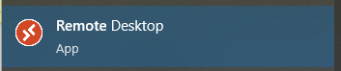
3 | TBDIR UserID and password | The user login will be username@tbdir.net and password, it will redirect to the MFA for authentication. Enter the MFA code then you will be able to get the Assigned resource.

Install RD Client from Microsoft in BYOD devices
- Download the RD client from internet using following link:
https://go.microsoft.com/fwlink/?linkid=2068602
- Right click RemoteDesktop_1.2.xxxx.0_x64.msi file and choose the install option.
- Click Next to follow the RD client installation wizard.

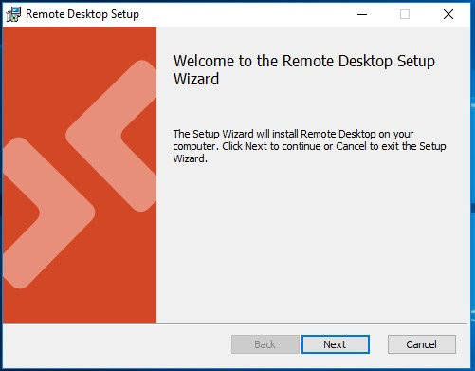

- Accept the License Agreement checkbox and click next proceed.
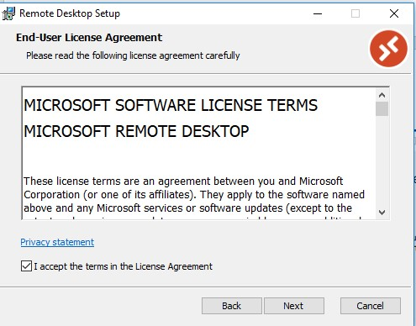
- It has Important to choose the option highlighted below in “Yellow” option and click install button to start the installation.
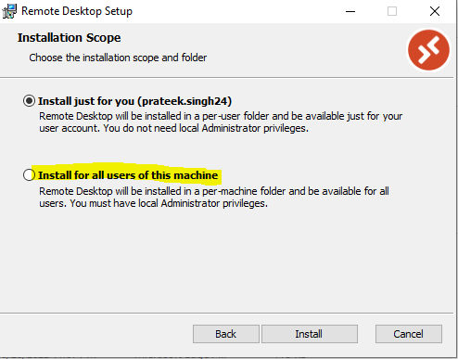

- Click on finish to complete RD client installation wizard.
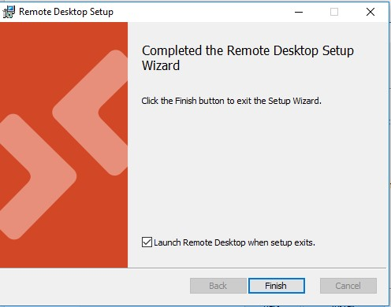

Install RD client from Company portal in DTAG owned devices
- Open Company Portal search Remote Desktop in company portal and install it.
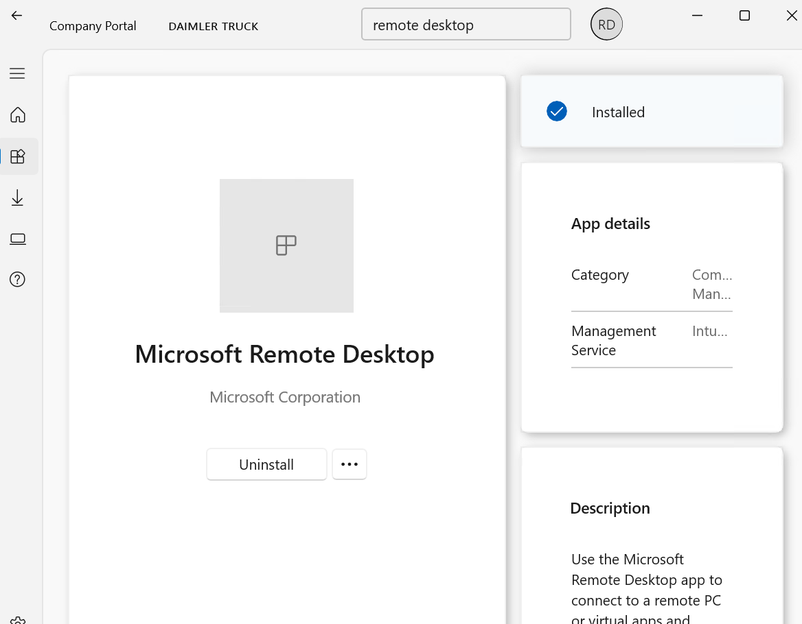

Login & Access VDI
- Click on Subscribe

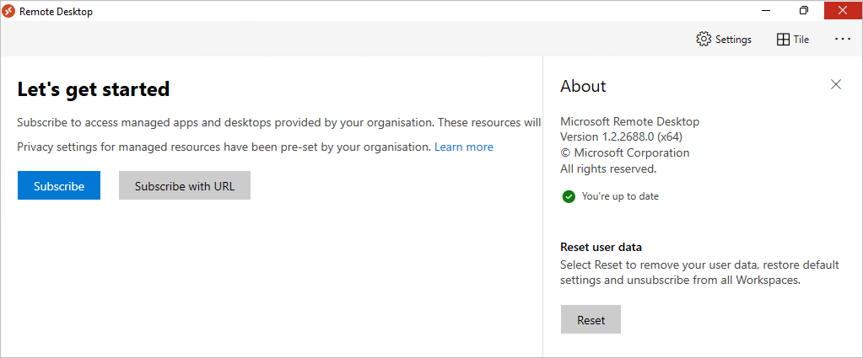

- Enter your shortid@tbdir.net and password
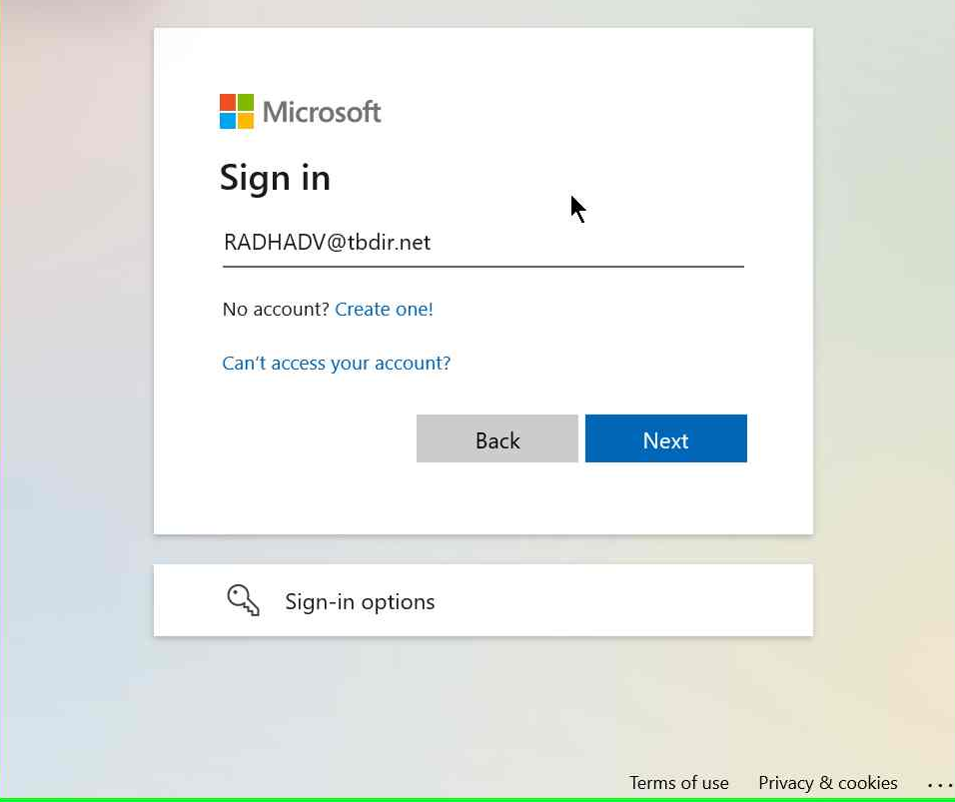

- It will redirect to Authenticator page, enter the MFA code and approve it.
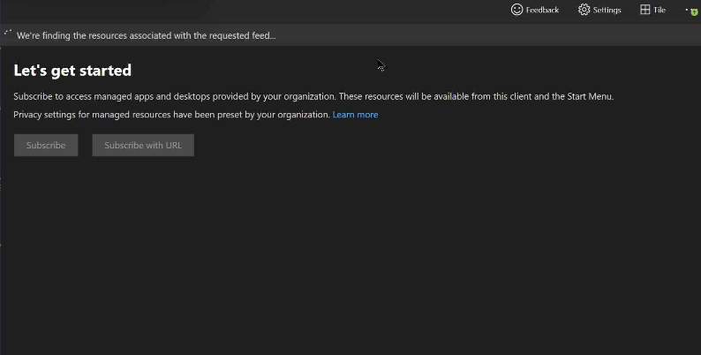

- Access the VDI post successful authentication, you will find your VDI. Start with a double click the session to your virtual PC.
Note – you will get the VDI assigned based on your role.
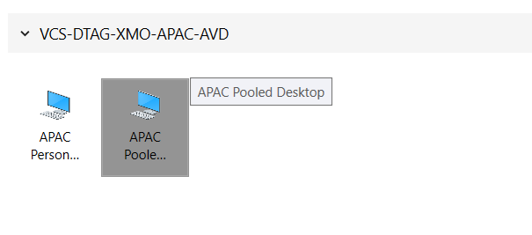

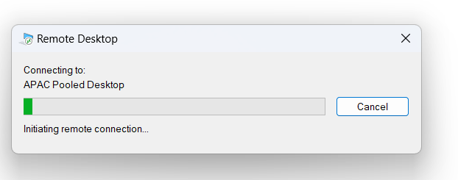

Custom settings in Remote desktop client

Set VDI to launch in only desired screen when you have multiple monitor

- Right click on VDI name you to set and select settings

- Then Disable “Default settings” and change the Display Configuration to “Single Display / Select Display”.
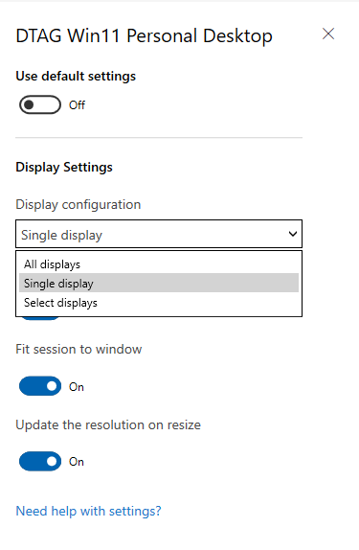
  - Select display allows to set to your preferred monitor, and from next logon VDI will launch from that monitor

Change multi-screen to single screen
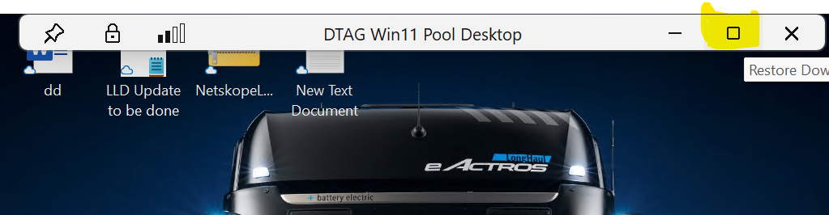
- Restore down and drag VDI to desired screen

- Right click on top barDisplay settingsSelect ‘Maximize to current displays’

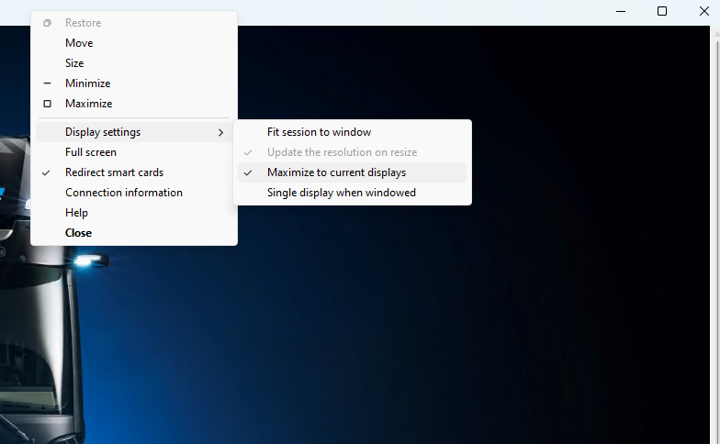

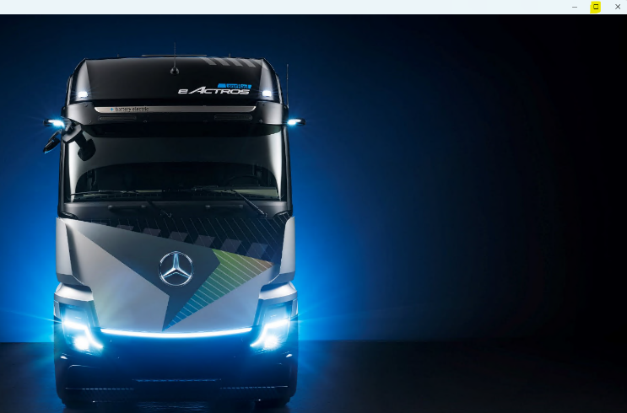

Access windows Key combination (Windows, Alt+Tab) in AVD VDI session

- You can use Windows key combination from your laptop when AVD VDI session is set to Full screen mode.
- Make sure VDI is in full screen mode
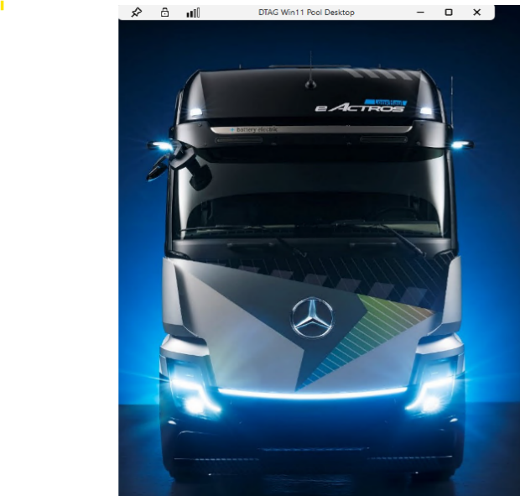

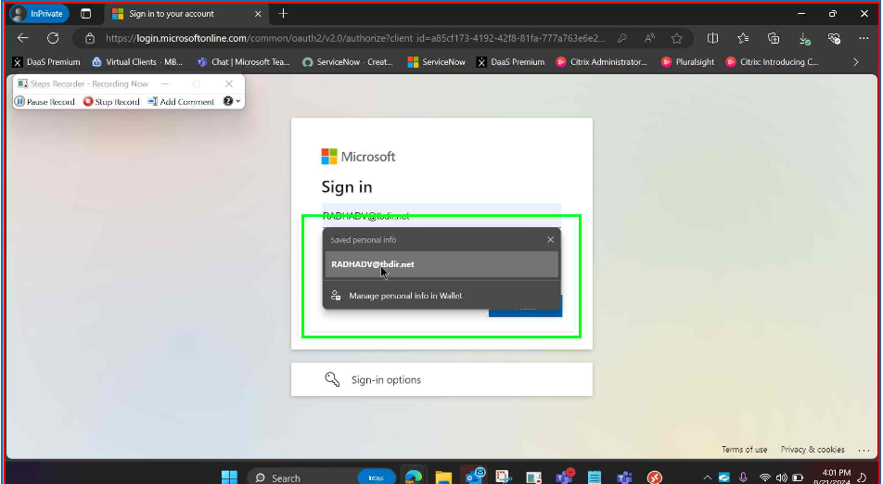

- Start using Windows Key combination like Press Alt+tab or Windows

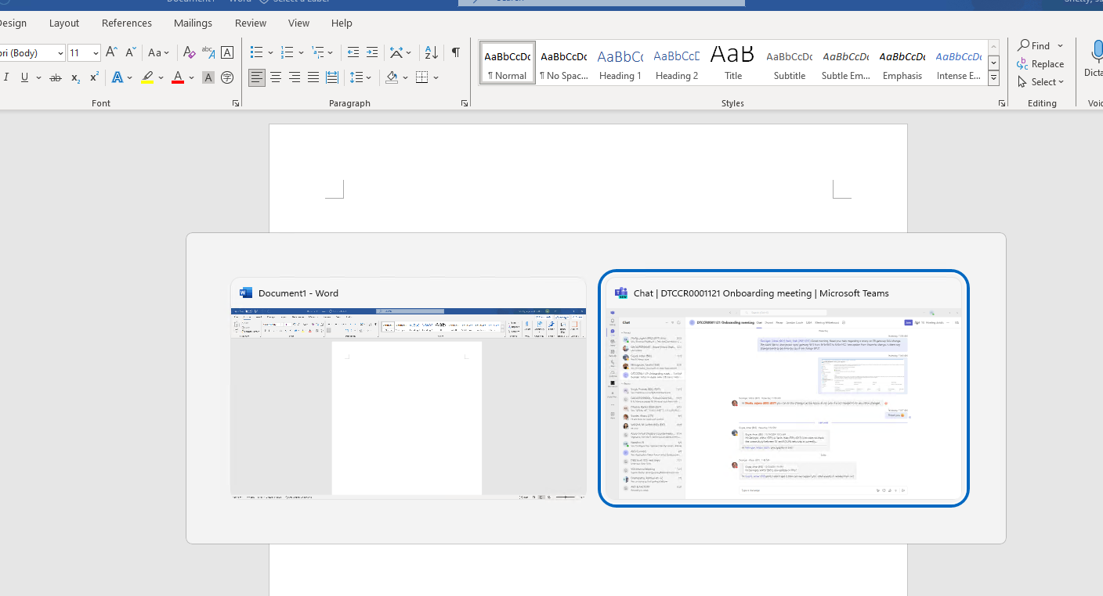

Access Via Web client

Prerequisites
The following pre-requisites are required for access to the new environment:
No | Title | Description
1 | Address for the browser | Use the below mentioned URL in a browser    https://client.wvd.microsoft.com/arm/webclient/index.html  It is recommended to use Google Chrome/Microsoft Edge
3 | TBDIR UserID and password | The user login will be username@tbdir.net and password, it will redirect to the MFA for authentication. Enter the MFA code then you will be able to get the Assigned resource.

Login via Web Client access VDI

- Open a browser (preferred Edge/Chrome) and enter below URL:

https://client.wvd.microsoft.com/arm/webclient/index.html
Enter your shortID@tbdir.net in sign-in page
- Authenticate to portal Below window will appear, put the username@tbdir.net
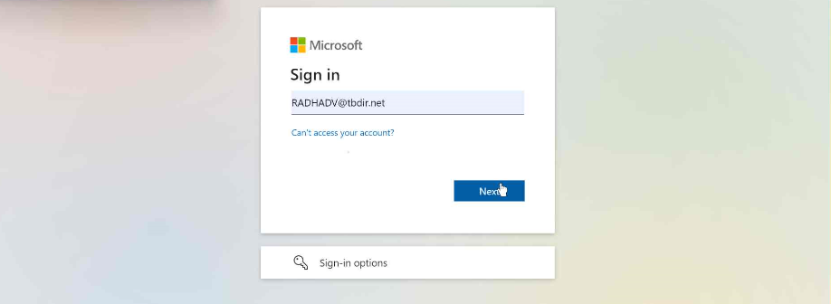
- You will be redirected to Authenticator page, enter your MFA code and approve.
- Access the VDI post successful authentication, you will find your VDI. Start with a double click the session to your virtual PC.
Note – you will get the VDI assigned based on your role
- Upon clicking on the desktop, you will be asking to allow the resources (refer below) and click “Allow”

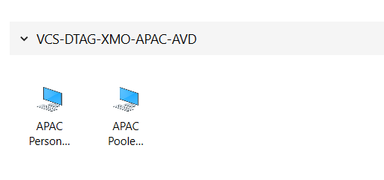
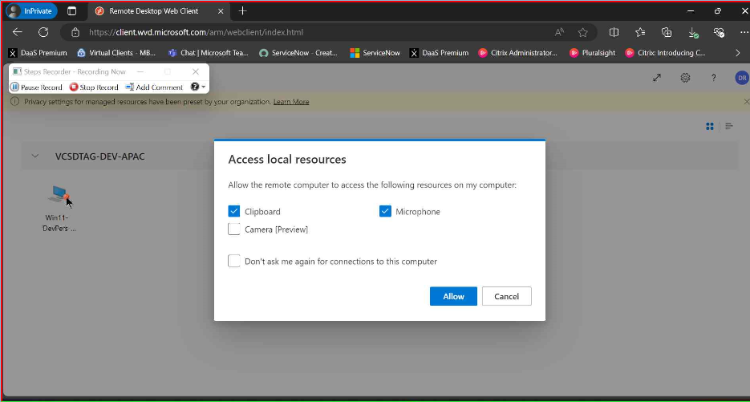

After successful authentication & logon process, you will be logged into the VDI.

Contact VCS AVD Team:

SNOW Process:

- Open Daimler Truck Service now portal and select Somethings is broken
Service Portal - DAIMLER TRUCK SERVICE PORTAL
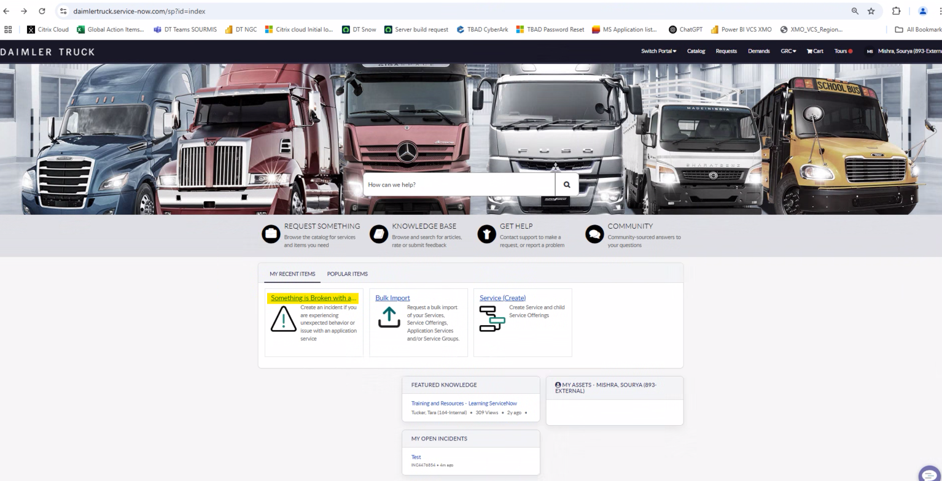
- Fill in the required details as mentioned in below screenshot
Application Service: APAC Regional Service-VCS - Production
Location Type: My Region
Configuration Item: APAC Regional Service-VCS – Production
Short Description: “Type in brief summary of the issue”
Description: “Type detailed information about the issue with below details included”
User ID
VDI Name you see in remote desktop or web client
Application name if issue is specific to application.
Issue description
Error message screen shot.
Number of users affected.
User location

Once all details are filled, click on submit.
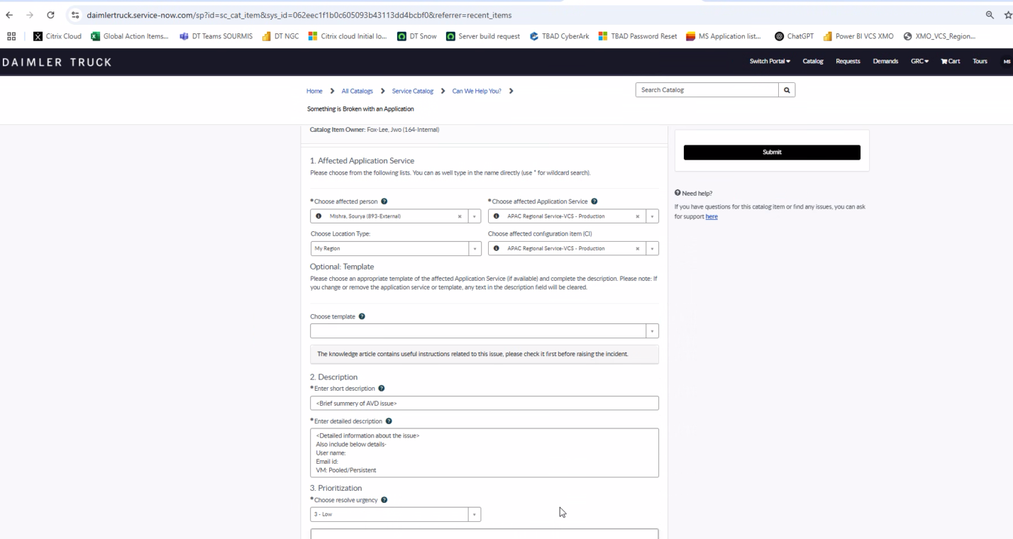
- Incident will be created in Daimler Service now to SD team, SD team will further assign this ticket to our queue.
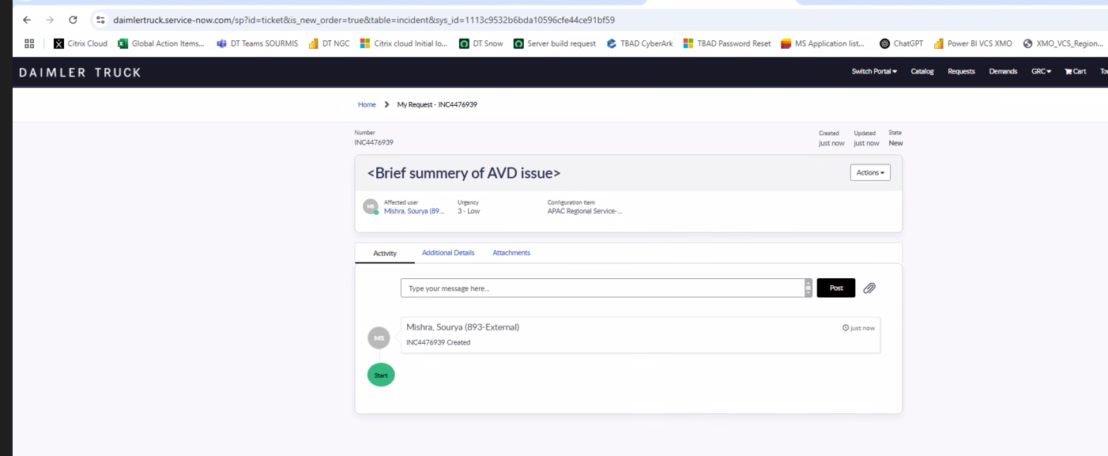

NPM mailbox:
Please contact us for issues and more information on below NPM mailbox.
XMO_VCS_APAC@infosys.com
Please include below details for better support
User ID
VDI Name you see in remote desktop or web client
Application name if issue is specific to application.
Issue description
Error message screen shot.
Number of users affected.
User location

Frequently Asked Questions:
- Is Remote Desktop Client required to access AVD VDI?
No, not required but it is recommended to use RD Client to access the VDI.
- Do i need VPN connection to connect XMO VCS AVD VDI?
No, it is not required.
- Do i need internet access to connect the XMO VCS AVD VDI?
Yes.
- How can i access the XMO VCS AVD VDI?
You can use the Remote Desktop Client or by using the following link.
https://client.wvd.microsoft.com/arm/webclient/index.html
- What is the list of supported browsers?
Microsoft Edge
Google Chrome, Safari

Basic Issues which you may face in VDI

- Error- Unable to copy/paste the text, files or documents from VDI to local machine and local machine to VDI.
Solution- The design of our environment prevents direct copying and pasting from local machines to AVD VDIs and vice versa. For file and data transfers, please utilize OneDrive or another designated data transfer (DT) approved method.

- Error- Printer, USB redirection is not working in VDI.
Solution- In accordance with established design specifications, both printer and USB redirection from local machines to AVD VDIs are disabled within this environment.

- Error- User is facing the slowness issue/ VDI performance issue/ Latency Issue.
Solution- If you are facing the slowness issue then there could be multiple reason, please follow the below steps before creating the ticket –
- Kindly ensure a stable internet connection. Attempt switching networks to verify connectivity. If the issue persists, please proceed with the next steps.
- If utilizing the Remote Desktop Client (RD Client), please ensure it is updated to the latest version. If this point doesn’t work, then follow the below steps.
- Please terminate your current VDI session correctly. To do so, sign out of the VDI or enter the "logoff" in search. Please make sure to do not close the VDI directly.
If the above steps are not working, then create a ticket for the issue.

- Error – User is facing the frequently session disconnection issue just after login. User is getting the reconnect popup window.
Solution - If user is facing the frequent session disconnection issue after login, please follow the below steps before creating the ticket –
- Kindly ensure a stable internet connection. Attempt switching the networks to other network to verify the connectivity. If the issue persists, please proceed with the next steps.
- If you are using the web client, then please use the Remote desktop client.
If the above steps are not working, then create a ticket for the issue.
- Error - User is unable to login on VDI with the username and password.
Solution – If a user encounters login difficulties using their username and password, this may be due to password expiration or a forgotten password. In such cases, users need to reset password through the appropriate self-service mechanism or contact the local IT support team for assistance with a password reset.

- Error – Office activation failure
Solution – Kindly verify the Microsoft 365 license is assigned. If licenses are not currently assigned, please contact your local IT support team to request assignment

- Error - Internet is not working in any browser.
Solution- Please follow the below steps before creating the incident.

- Netskope Status Check: Verify whether Netskope is currently disabled or enabled.
- Netskope Disabled: If Netskope is disabled, please confirm whether a user mailbox has been created. If a mailbox has not been created, please contact your local IT support team to request mailbox creation.

- Error - User is getting the Black screen after logging in the VDI.
Solution- If user is getting the black screen after logging, then please check the below steps before creating a ticket –
- Kindly ensure a stable internet connection. Attempt switching the networks to other network to verify the connectivity. If this point doesn’t work, then follow the below steps.
- If you are utilizing the Remote Desktop Client, please ensure that it is upgraded to the latest version and subsequently reset. If you are accessing the remote desktop via a web browser, please use the recommended remote desktop client.
- Please close the RD Client or web client for at least 15 minutes and then check again.
If the above steps are not working, then create a ticket for the issue.

